Unit III: Convolution Neural Network (CNN)

Question: Define convolutional neural network (CNN), and how does it differ from other types of neural networks? (May 2024)

1. Definition / Introduction
A Convolutional Neural Network (CNN) is a specialized architecture of deep artificial neural networks designed primarily for processing structured arrays of data, such as images. It is characterized by its ability to automatically and adaptively learn spatial hierarchies of features—ranging from low-level edges to complex objects—through a process called backpropagation.
In the context of modern engineering, CNNs serve as the fundamental building block for computer vision tasks. They utilize mathematical convolution operations instead of general matrix multiplication in at least one of their layers, allowing the network to maintain the spatial relationship between pixels while significantly reducing the computational load.

2. Detailed Explanation
To understand how a CNN differs from other networks, such as standard Multi-Layer Perceptrons (MLPs), we must examine its internal mechanisms:

A. The Convolution Operation
Unlike traditional networks that treat every input feature independently, CNNs use a “filter” or “kernel”. This small matrix slides across the input image, performing element-wise multiplication and summation. This process generates a Feature Map, which highlights specific patterns (like horizontal lines or curves) regardless of where they appear in the image.

B. Hierarchical Feature Learning
CNNs are typically structured in a series of stages:
- Lower Layers: Detect simple features like edges, colors, and textures.
- Middle Layers: Combine edges to detect motifs and parts of objects (e.g., a nose or a wheel).
- Higher Layers: Assemble these parts into recognizable objects (e.g., a face or a car).

C. Structural Differences from Standard Neural Networks
The primary distinction lies in how neurons are connected. In a standard Feedforward Network (MLP), every neuron in one layer is connected to every neuron in the next. For a high-resolution image, this would result in an unmanageable number of weights (parameters), leading to overfitting and extreme computational costs.
CNNs overcome this through:
- Local Connectivity: Each neuron only “sees” a small local region of the input.
- Shared Weights: The same set of weights (the filter) is applied across the entire input, which assumes that a feature learned in one part of an image is useful in another.

3. Key Points
- Spatial Awareness: CNNs preserve the 2D/3D structure of the input data, whereas other networks flatten the input into a 1D vector, losing spatial context.
- Automatic Feature Extraction: CNNs eliminate the need for manual feature engineering; they learn the best filters for the task during training.
- Parameter Efficiency: Due to weight sharing and local connectivity, CNNs have far fewer parameters than fully connected networks of similar depth, making them easier to train.
- Translation Invariance: They can recognize an object even if it is shifted or tilted within the frame.
- Sparsity of Connections: CNNs focus on local patterns, which captures local dependencies much more efficiently than global connection strategies.

4. Diagram
The following diagram illustrates the structural differences between a fully connected layer (standard NN) and a convolutional layer.

5. Conclusion / Summary
In conclusion, a Convolutional Neural Network is a specialized tool for grid-like data that replaces the “global” connection strategy of standard neural networks with a “local” and “shared” strategy. By mimicking the biological visual cortex and focusing on spatial hierarchies, CNNs achieve superior performance in image-related tasks while maintaining high parameter efficiency. This architectural shift is what allows modern AI to achieve human-level accuracy in image recognition and classification.

Question: What is the main purpose of using CNNs in deep learning? (May 2024)

1. Definition / Introduction
The main purpose of a Convolutional Neural Network (CNN) is to process and extract meaningful patterns from data with a grid-like topology, such as images, by preserving spatial relationships. Unlike standard neural networks that treat each pixel as an independent feature, CNNs are designed to automatically and adaptively learn spatial hierarchies of features.
In the context of deep learning, CNNs serve as highly efficient feature extractors that translate raw pixel data into high-level abstractions suitable for complex tasks like object detection, image classification, and medical diagnosis.

2. Detailed Explanation
The primary objective of using CNNs over other architectures involves solving specific challenges inherent in high-dimensional visual data:

A. Automated Feature Engineering
In traditional machine learning, engineers had to manually design “hand-crafted” filters to detect edges or textures. The core purpose of a CNN is to eliminate manual feature extraction. During the training process, the network learns which filters (kernels) are most effective for identifying relevant patterns in the specific dataset provided.

B. Preservation of Spatial Context
Standard Feedforward Networks (MLPs) require flattening a 2D image into a 1D vector, which destroys the spatial relationship between neighboring pixels. The purpose of the convolution operation is to slide a filter across the input to produce a Feature Map, ensuring that the network understands that a group of pixels represents a single entity, like an eye or a wing, based on their relative positions.

C. Handling High-Dimensionality
Visual data is computationally expensive. An image of $100×100$ pixels has 10,000 inputs; in an MLP, this would lead to millions of parameters in the first hidden layer alone, causing overfitting. CNNs use Shared Weights and Local Connectivity to reduce the number of parameters significantly, allowing the network to scale to deep architectures without an unmanageable computational load.

3. Key Points
- Hierarchical Learning: Captures simple features (edges) in early layers and complex features (objects) in deeper layers.
- Translation Invariance: Recognizes objects regardless of their position, tilt, or slight shifts within the frame.
- Efficiency: Uses weight sharing so that a single filter can detect the same feature across the entire image, reducing total parameters.
- Dimensionality Reduction: Uses pooling layers to reduce the spatial size of the representation, focusing on the most important information.
- Structural Optimization: Specifically tailored for “grid-like” data, making them the standard tool for computer vision.

4. Diagram
The following diagram illustrates how the purpose of a CNN is fulfilled by moving from raw data to abstract classification through specialized layers.
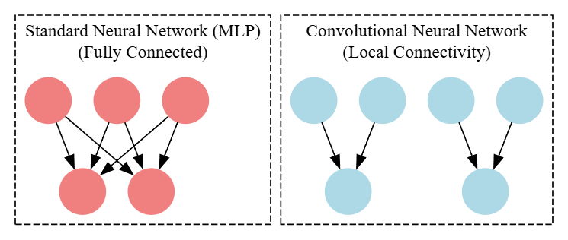

5. Conclusion / Summary
In summary, the main purpose of using CNNs is to provide a computationally efficient and spatially aware framework for automated feature extraction. By leveraging local connectivity and shared weights, CNNs overcome the limitations of traditional networks, allowing deep learning models to achieve human-level accuracy in interpreting complex visual information while maintaining high parameter efficiency.

Question: Explain the basic architecture of a Convolutional Neural Network (CNN) and describe the role of each key component within the architecture. (May 2025)

1. Definition / Introduction
The architecture of a Convolutional Neural Network (CNN) is a hierarchical structure specifically engineered to process data with a grid-like topology. Unlike traditional neural networks, a CNN architecture is composed of specialized layers that perform feature extraction and spatial reasoning automatically.
The primary objective of this architecture is to take a high-dimensional input (like an image) and transform it into a compact representation or a specific class prediction. This is achieved by stacking multiple layers that progressively abstract the input data into higher-level features.

2. Detailed Explanation
A standard CNN architecture is divided into two main sections: Feature Extraction (Convolutional Base) and Classification (Dense Head). Each component within these sections plays a distinct role:

A. Convolutional Layer (The Core Building Block)
This is the first component of the architecture. It consists of a set of learnable filters (kernels).
- Role: Each filter slides across the width and height of the input volume and computes a dot product between the entries of the filter and the input.
- Result: It produces a 2D activation map (Feature Map) that detects specific visual features like edges, curves, or textures.

B. Activation Function Layer (Non-linearity)
Most CNN architectures apply an activation function, usually the Rectified Linear Unit (ReLU), immediately after each convolution.
- Role: It introduces non-linearity into the system, allowing the network to learn complex patterns. Since convolution is a linear operation, ReLU ensures the network can model data that isn’t just a linear combination of inputs.

C. Pooling Layer (Downsampling)
Pooling layers are inserted periodically between successive convolutional layers.
- Role: They reduce the spatial size (Width and Height) of the representation to reduce the number of parameters and computation in the network.
- Common Methods: Max Pooling (takes the maximum value from a window) and Average Pooling.

D. Fully Connected (FC) Layer
After several convolutional and pooling layers, the high-level reasoning in the neural network is done via FC layers.
- Role: Neurons in this layer have full connections to all activations in the previous layer. They act as a traditional MLP that uses the features extracted by the previous layers to classify the input into target classes.

E. Flattening Layer
- Role: This acts as a bridge between the convolutional base and the dense head. It converts the multi-dimensional feature maps into a 1D vector so they can be fed into the Fully Connected layers.

3. Key Points
- Spatial Hierarchy: The architecture is designed so that earlier layers detect local patterns (edges) while later layers detect global patterns (objects).
- Weight Sharing: Filters are reused across the entire input, which drastically reduces the total number of trainable parameters.
- Receptive Field: As we move deeper into the architecture, each neuron is influenced by a larger portion of the original input image.
- Parameter Efficiency: Compared to a fully connected network, the CNN architecture is far more efficient at handling high-resolution inputs.

4. Diagram
The following diagram represents the standard sequential flow of a CNN architecture from an input image to a final class output.

5. Conclusion / Summary
In conclusion, the architecture of a CNN is a sophisticated pipeline where Convolutional and Pooling layers act as an automated feature extractor, and Fully Connected layers act as the decision-maker. By organizing these components in a specific sequence, the CNN can effectively handle the high dimensionality of visual data while maintaining spatial context, making it the gold standard for modern image recognition systems.

Question: Describe the typical architecture of a CNN. (May 2024) (Repeated Question)

1. Definition / Introduction
A Convolutional Neural Network (CNN) architecture is a deep learning framework specifically designed to process data with a grid-like topology, such as images. Unlike standard neural networks that use a flat, fully connected structure for all layers, a typical CNN architecture is composed of a series of specialized layers that perform automated feature extraction and spatial reasoning.
The context of this architecture is to transform raw input pixels into high-level abstractions. It achieves this through a hierarchical design where the initial layers capture simple patterns (edges/textures) and deeper layers integrate these into complex object representations.

2. Detailed Explanation
A typical CNN architecture is conceptually divided into two functional parts: the Feature Extraction (Convolutional Base) and the Classification (Dense Head).

A. The Feature Extraction Section
This section consists of repetitive blocks of layers that reduce the spatial dimension while increasing the depth of the feature maps:
- Convolutional Layers: These are the primary building blocks. They use sets of learnable filters that slide across the input to detect local patterns and produce “Feature Maps”.
- Activation Layers (ReLU): Applied immediately after a convolution. The Rectified Linear Unit (ReLU) introduces non-linearity, allowing the network to learn complex, non-linear relationships in the data.
- Pooling Layers: These perform downsampling. They reduce the spatial size (Width $×$ Height) of the feature maps, which minimizes the number of parameters and provides a degree of translation invariance.

B. The Classification Section
Once the features are extracted, the architecture transitions to a global decision-making structure:
- Flattening Layer: This layer serves as a bridge. It converts the 3D feature maps (Width $×$ Height $×$ Depth) into a 1D vector suitable for traditional neural network layers.
- Fully Connected (FC) Layers: These layers act as a traditional Multi-Layer Perceptron (MLP). They utilize the high-level features provided by the convolutional base to perform the final classification task.
- Output Layer: Usually employs a Softmax activation function for multi-class classification to provide probability distributions over the target classes.

3. Key Points
- Hierarchical Structure: Features move from low-level (edges) to high-level (objects) as they progress through the architecture.
- Weight Sharing: The same filters are applied across the entire image, drastically reducing the total parameter count compared to fully connected networks.
- Local Connectivity: Each neuron is only connected to a small region of the input, allowing the model to focus on local spatial correlations.
- Spatial Sub-sampling: Pooling layers ensure that the network is robust to small shifts or distortions in the input image.
- Modular Design: The architecture is often built by interleaving Convolutional, ReLU, and Pooling layers in a sequential manner.

4. Diagram
The following Graphviz code represents the typical sequential flow of a CNN architecture from input to classification.

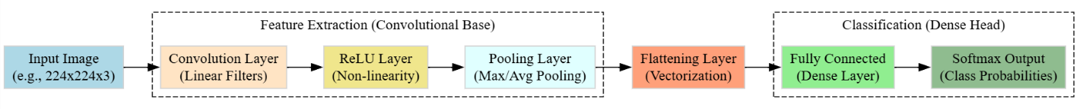

5. Conclusion / Summary
In summary, a typical CNN architecture is a highly optimized pipeline that replaces the global connectivity of standard networks with a localized, hierarchical approach. By stacking Convolutional, Activation, and Pooling layers to extract features, followed by Fully Connected layers for classification, the architecture efficiently manages the high dimensionality of visual data while maintaining essential spatial context. This structure remains the standard for achieving state-of-the-art results in modern computer vision tasks.

Topic: The Basic Structure of a Convolutional Network

1. Definition / Introduction
The Basic Structure of a Convolutional Network refers to the specific arrangement of specialized layers designed to process data with a known grid-like topology. Unlike standard feedforward neural networks that utilize global connectivity, the structure of a CNN is built upon the principle of local connectivity and parameter sharing.
At its core, the structure is designed to perform a series of transformations: moving from raw input pixels to local feature maps, then to downsampled representations, and finally to a global class prediction. This structure allows the network to be spatially aware and computationally efficient.

2. Detailed Explanation
A standard convolutional network structure is composed of a repeating sequence of primary layers. The mathematical logic of this structure is governed by the relationship between the input, the filter, and the resulting output dimensions.

A. The Convolutional Layer (The Foundation)
The primary structural component is the convolutional layer. It consists of a set of learnable Filters (Kernels).
- The Operation: As the filter slides (convolves) over the input, it computes the dot product between the filter weights and the local input region.
- Feature Maps: The output of this layer is a 3D volume of “Activation Maps” or “Feature Maps.” Each map represents the response of one filter across the entire spatial extent of the input.

B. Architectural Hyperparameters (Padding & Strides)
The structure of the network is physically shaped by these two settings:
- Padding: Adding “dummy” pixels (usually zeros) around the border of the input. This is done to ensure the output feature map has the same spatial dimensions as the input or to prevent information loss at the edges.
- Strides: The step size with which the filter moves. A stride of 1 moves the filter one pixel at a time, while a stride of 2 skips one pixel, effectively halving the output resolution.

C. The Activation Layer (ReLU)
Structurally, every linear convolution is followed by a non-linear activation function, most commonly the Rectified Linear Unit (ReLU). It maps all negative values to zero while keeping positive values unchanged, allowing the structure to learn complex non-linear mappings.

D. The Pooling Layer (Spatial Reduction)
This layer is periodically inserted to reduce the spatial size of the representation.
- Function: It summarizes the features in a local region. For example, Max Pooling keeps only the most prominent feature in a $2×2$ window.
- Structural Purpose: It makes the network more robust to small translations of the input and reduces the memory footprint.

E. The Fully Connected Layer (Global Synthesis)
The final part of the structure flattens the 3D volume into a 1D vector. These layers act as a standard classifier that looks at the “big picture” (the features extracted by previous layers) to make a final decision.

3. Key Points
- Local Receptive Fields: Neurons only connect to a small local patch of the previous layer, mimicking the human visual system.
- Weight Sharing: The same filter is used for every position in the input, which drastically reduces the number of parameters compared to fully connected networks.
- 3D Volume Input: CNN structures always treat inputs as volumes with dimensions (Height $×$ Width $×$ Depth).
- Feature Hierarchy: The structure is deep, meaning it learns to stack simple features into complex ones as data flows through the layers.
- Translation Invariance: The combination of convolution and pooling helps the network recognize a feature regardless of its exact location in the grid.

4. Diagram
The following diagram highlights the structural blocks of a standard convolutional network.


5. Conclusion / Summary
In conclusion, the Basic Structure of a Convolutional Network is a highly efficient, hierarchical pipeline. By interleaving convolutional layers for feature extraction, ReLU for non-linearity, and pooling for dimensionality reduction, the network can effectively process high-dimensional visual data. This structural design ensures that the model is both powerful enough to recognize complex patterns and efficient enough to be trained on modern hardware.

Question: How do you determine the number of filters in each convolutional layer? (May 2024)

1. Definition / Introduction
In a Convolutional Neural Network (CNN), a filter (also known as a kernel) is a small matrix of learnable weights that slides across the input data to detect specific features. The number of filters in a convolutional layer defines the “depth” of the output feature map, with each individual filter responsible for extracting a unique type of visual feature.
Determining the appropriate number of filters is a critical part of architectural design. It involves balancing the model’s capacity to learn complex patterns against the computational cost and the risk of overfitting.

2. Detailed Explanation
Choosing the number of filters is often an empirical process guided by established architectural patterns and the complexity of the input data.

A. Hierarchical Complexity
The number of filters typically increases as we move deeper into the network.
- Initial Layers: These layers focus on low-level features like edges, lines, and simple textures. Because there are fewer variations of these basic patterns, a smaller number of filters (e.g., 32 or 64) is usually sufficient.
- Deeper Layers: As the network progresses, it combines low-level features into complex shapes and objects. To capture the vast variety of these complex abstractions, the number of filters is increased (e.g., 128, 256, or 512).

B. The Power of Two Rule
By convention, researchers and engineers typically select the number of filters in powers of two ($2^{n}$), such as 32, 64, 128, 256, or 512. This is primarily for computational efficiency, as many deep learning libraries and hardware accelerators (like GPUs) are optimized for processing data in these sizes.

C. Balancing Information and Computation
The decision is also influenced by the “curse of dimensionality”.
- Too Few Filters: The network may suffer from underfitting, failing to capture essential features required for accurate classification or detection.
- Too Many Filters: This leads to a massive increase in the number of parameters, which consumes excessive memory, increases training time, and significantly raises the risk of overfitting the training data.

D. Influence of Feature Map Size
As spatial dimensions (Height and Width) decrease through pooling and strides, it is common practice to increase the number of filters (Depth). This ensures that the total “volume” of information is preserved or enriched even as the spatial resolution is compressed.

3. Key Points
- Feature Diversity: Each filter acts as a feature detector; more filters allow the network to recognize more varied patterns.
- Layer Depth: The number of filters usually doubles after a pooling layer to compensate for the loss of spatial information.
- Empirical Tuning: Often determined through trial and error, cross-validation, or by following successful standard architectures like VGG or ResNet.
- Dataset Size: Larger datasets can generally support a higher number of filters without overfitting compared to smaller datasets.
- Computational Constraints: The available GPU memory and processing power often set an upper limit on the total number of filters used across the network.

4. Diagram / Example
Example: In a typical image classification task for $224×224$ images:
- Layer 1: 64 filters to detect basic edges.
- Pooling Layer: Reduces spatial size to $112×112$.
- Layer 2: 128 filters to detect more complex textures.
- Pooling Layer: Reduces spatial size to $56×56$.
- Layer 3: 256 filters to detect object parts.
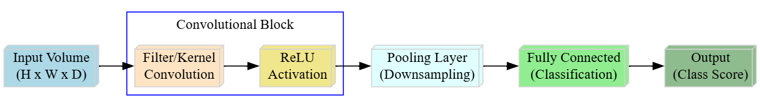

5. Conclusion / Summary
Determining the number of filters is a strategic choice that follows a hierarchical approach: fewer filters for low-level features in early layers and more filters for complex abstractions in deeper layers. While generally guided by the “power of two” convention and standard architectures, the final number must be optimized to provide enough representational power for the specific task while remaining within the computational limits of the hardware.

Question: Define padding and strides in CNNs, and explain their impact on the output size of feature maps in convolutional layers. (May 2025)

1. Definition / Introduction
Padding and Strides are critical architectural hyperparameters in a Convolutional Neural Network that physically shape the dimensions of the output feature maps. Padding refers to the process of adding extra “dummy” pixels (typically zeros) around the perimeter of an input image before the convolution operation begins. Its primary purpose is to preserve spatial information at the borders and control the output size.
Strides, on the other hand, define the step size or the number of pixels by which the convolutional filter shifts as it slides across the input. While a default stride of 1 moves the filter incrementally, larger strides act as a form of downsampling by skipping input pixels.

2. Detailed Explanation

A. Padding: Mechanics and Types
Padding addresses the “border effect” where pixels at the edges of an image are only covered once by a filter, whereas central pixels are covered multiple times.
- Valid Padding (No Padding): The filter stays strictly within the boundaries of the input. This results in an output feature map that is smaller than the input.
- Same Padding (Zero Padding): Zeros are added around the border such that the output feature map has the same spatial dimensions (Width and Height) as the input.
- Impact: Without padding, deep networks would cause the feature map dimensions to shrink to $1×1$ too quickly, losing essential spatial data.

B. Strides: Mechanics and Downsampling
Strides determine the density of the convolution operation across the spatial dimensions.
- Stride of 1: The filter moves one pixel at a time. This produces a dense feature map that retains most of the spatial detail.
- Stride of 2 or more: The filter skips pixels (e.g., a stride of 2 moves two pixels at a time). This effectively halves the resolution of the output.
- Impact: Higher strides reduce the computational load and memory footprint by producing smaller output volumes, serving a similar purpose to pooling layers.

C. Mathematical Impact on Output Size
The dimensions of the output feature map $\left(O\right)$ are calculated based on the input size $\left(I\right)$, filter size $\left(F\right)$, padding $\left(P\right)$, and stride $\left(S\right)$ using the following formula:
$$O=\left\lfloor \frac{I-F+2P}{S}\right\rfloor +1$$
- Increasing Padding ($P$): Increases the numerator, thereby increasing the output size $O$.
- Increasing Stride ($S$): Increases the denominator, which significantly decreases the output size $O$.

3. Key Points
- Spatial Preservation: Padding ensures that features located at the very edge of an image are not discarded during the convolution process.
- Computational Efficiency: Strides are used to aggressively reduce the dimensionality of feature maps, which speeds up training and reduces the risk of overfitting.
- Volume Enrichment: As strides decrease spatial resolution, it is common practice to increase the number of filters (Depth) to preserve the total “volume” of information.
- Architectural Control: These two parameters allow researchers to precisely design how information is compressed as it flows through the hierarchical layers of the CNN.

4. Diagram / Example
The following Graphviz code illustrates a $3×3$ filter applied to a $5×5$ input with Padding=1 and Stride=2.

5. Conclusion / Summary
In summary, Padding and Strides are the primary tools for controlling the spatial dimensions of data within a CNN. While padding prevents information loss at the borders and maintains resolution, strides provide a mechanism for controlled downsampling. Mastering the interplay between these two settings is essential for building deep architectures that are both computationally efficient and capable of retaining critical spatial hierarchies.

Question: Explain the concept of padding in CNNs. Why is it used? (May 2024) (Repeated Question)

1. Definition / Introduction
Padding is a technique used in Convolutional Neural Networks (CNNs) where extra “dummy” pixels—typically with a value of zero—are added around the outer boundary of an input image or feature map before the convolution operation is performed.
In a standard convolution, the spatial dimensions of the output are naturally smaller than the input. Padding allows engineers to modify this behavior, providing a mechanism to control the output volume size and ensure that the structural integrity of the data is maintained as it passes through deep layers.

2. Detailed Explanation
The concept of padding arises from two primary issues encountered during the convolution process: Spatial Shrinkage and Loss of Border Information.

A. Mechanics of Padding
When a filter (kernel) of size $F×F$ slides over an input of size $I×I$, the filter can only stay within the bounds of the pixels. Without padding, the output size $O$ is calculated as $O=I-F+1$. By adding $P$ layers of zeros around the edge, the effective input size becomes $\left(I+2P\right)$. The new output size becomes:
$$O=\left(I+2P-F\right)+1$$

B. Types of Padding
- Valid Padding (No Padding): No zeros are added ($P=0$). The filter stays strictly inside the input. This results in the maximum reduction of the feature map size.
- Same Padding (Zero Padding): A specific amount of padding is added so that the output spatial dimensions are exactly the same as the input dimensions ($O=I$). For a stride of 1, this is achieved by setting $P=\left(F-1\right)/2$.
- Full Padding: The filter is allowed to slide such that even if only one pixel of the filter overlaps with the input, a convolution is performed. This results in an output larger than the input.

C. Why Padding is Used (The “Why”)
- Preventing Dimensionality Collapse: In deep networks with dozens of layers, the feature map would shrink to $1×1$ very quickly without padding. Padding allows the network to be “deep” by maintaining the spatial resolution across layers.
- Preserving Border Information: Without padding, pixels at the corners and edges are only “seen” by the filter once, whereas central pixels are overlapped multiple times. This means information at the edges is essentially discarded. Padding ensures edge pixels are treated with equal importance.

3. Key Points
- Zero Padding: The most common form, where the padded values are $0$, ensuring they do not contribute to the weighted sum in a way that biases the features.
- Border Effect Mitigation: Padding prevents the “eroding” of an image’s edges during successive convolutions.
- Architectural Flexibility: It allows for the design of “Symmetric” architectures where the input and output of a convolutional block have matching dimensions.
- Computation: While padding increases the number of operations slightly (due to a larger input area), the benefit of information retention far outweighs the cost.

4. Diagram / Example
The following diagram compares Valid Padding (where the image shrinks) versus Same Padding (where dimensions are preserved).

5. Conclusion / Summary
In summary, Padding is an essential structural tool in CNNs used to combat the natural shrinking effect of convolutions. By adding a border of zeros, it ensures that the network can grow deeper without losing spatial resolution and guarantees that information at the edges of the image is processed as effectively as the information at the center. It is the primary reason modern deep architectures can maintain high-resolution feature maps across hundreds of layers.

Topic: B. Strides

1. Definition / Introduction
Strides refer to a fundamental architectural hyperparameter in Convolutional Neural Networks (CNNs) that specifies the step size at which a convolutional filter (or kernel) moves across the input data. It determines the density of the convolution operation by controlling how many pixels the filter “skips” between successive computations.
In a standard configuration, a stride of 1 means the filter shifts one pixel at a time, ensuring maximum overlap and spatial detail. Conversely, larger strides (e.g., stride of 2) cause the filter to jump two pixels, effectively performing downsampling during the feature extraction phase.

2. Detailed Explanation
Strides play a dual role in both feature extraction and dimensionality management within the network architecture.

A. Mechanics of Stride Movement
When a filter is applied to an input volume, the stride value $\left(S\right)$ dictates the displacement of the kernel in both horizontal and vertical directions.
- Low Stride ($S=1$): The filter moves slowly, producing a high-resolution output feature map where neighboring neurons have highly overlapping receptive fields.
- High Stride ($S>1$): The filter moves aggressively across the input. This skipping mechanism reduces the number of applications of the filter, resulting in a smaller spatial dimension for the output feature map.

B. Impact on Spatial Dimensionality
The choice of stride has a drastic impact on the output size $\left(O\right)$. Increasing the stride increases the denominator in the standard output size formula:
$$O=\left\lfloor \frac{I-F+2P}{S}\right\rfloor +1$$
Where $I$ is input size, $F$ is filter size, and $P$ is padding. Doubling the stride roughly halves the output resolution, serving a functional purpose similar to pooling layers.

C. Computational Efficiency and Information Loss
Higher strides serve to reduce the computational load and memory footprint of the network by producing smaller output volumes. However, there is a trade-off: a very high stride may skip over fine-grained spatial details, potentially causing the network to miss small but critical features.

3. Key Points
- Downsampling Tool: Strides provide an alternative to pooling layers for reducing the spatial dimensions of feature maps.
- Receptive Field: Larger strides allow deeper neurons to cover a larger portion of the original input image more quickly.
- Parameter Efficiency: By reducing the output size, strides help in managing the number of parameters and overall computational cost in deep layers.
- Overlap Control: The stride value determines the degree of overlap between adjacent filter applications; $S<F$ ensures overlap, while $S=F$ results in no overlap.
- Typical Settings: Most modern architectures use a stride of 1 for standard convolutions and a stride of 2 when they specifically need to reduce spatial resolution.

4. Diagram / Example
The following diagram illustrates how a Stride of 2 affects the movement of a $3×3$ filter over a $7×7$ input (with no padding).
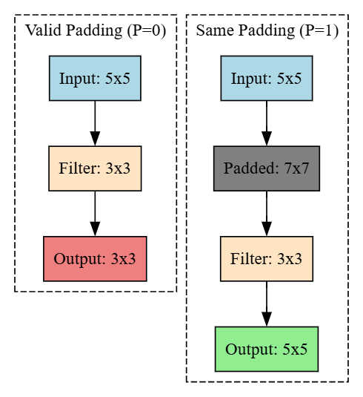

5. Conclusion / Summary
In summary, Strides are a powerful mechanism used to control the step-by-step movement of filters across an input volume. They are essential for balancing the preservation of spatial detail against the need for computational efficiency and dimensionality reduction. By strategically adjusting stride values, designers can precisely manage how information is compressed and abstracted as it flows through the hierarchical layers of a Convolutional Neural Network.

Question: What are strides in CNNs? (May 2024) (Repeated Question)

1. Definition / Introduction
Strides refer to a fundamental architectural hyperparameter in Convolutional Neural Networks (CNNs) that specifies the step size at which a convolutional filter (or kernel) moves across the input data. It determines the density of the convolution operation by controlling how many pixels the filter “skips” between successive computations.
In a standard configuration, a stride of 1 means the filter shifts one pixel at a time, ensuring maximum overlap and spatial detail. Conversely, larger strides (e.g., stride of 2) cause the filter to jump two pixels, effectively performing downsampling during the feature extraction phase.

2. Detailed Explanation
Strides play a dual role in both feature extraction and dimensionality management within the network architecture.

A. Mechanics of Stride Movement
When a filter is applied to an input volume, the stride value ($S$) dictates the displacement of the kernel in both horizontal and vertical directions.
- Low Stride ($S=1$): The filter moves slowly, producing a high-resolution output feature map where neighboring neurons have highly overlapping receptive fields.
- High Stride ($S>1$): The filter moves aggressively across the input. This skipping mechanism reduces the number of applications of the filter, resulting in a smaller spatial dimension for the output feature map.

B. Impact on Spatial Dimensionality
The choice of stride has a drastic impact on the output size ($O$). Increasing the stride increases the denominator in the standard output size formula:
$$O=\left\lfloor \frac{I-F+2P}{S}\right\rfloor +1$$
Where $I$ is input size, $F$ is filter size, $P$ is padding, and $S$ is stride. Doubling the stride roughly halves the output resolution, serving a functional purpose similar to pooling layers.

C. Computational Efficiency and Information Loss
Higher strides serve to reduce the computational load and memory footprint of the network by producing smaller output volumes. However, there is a trade-off: a very high stride may skip over fine-grained spatial details, potentially causing the network to miss small but critical features.

3. Key Points
- Downsampling Tool: Strides provide an alternative to pooling layers for reducing the spatial dimensions of feature maps.
- Receptive Field: Larger strides allow deeper neurons to cover a larger portion of the original input image more quickly.
- Parameter Efficiency: By reducing the output size, strides help in managing the number of parameters and overall computational cost in deep layers.
- Overlap Control: The stride value determines the degree of overlap between adjacent filter applications; $S<F$ ensures overlap, while $S=F$ results in no overlap.
- Typical Settings: Most modern architectures use a stride of 1 for standard convolutions and a stride of 2 when they specifically need to reduce spatial resolution.

4. Diagram / Example
The following diagram illustrates how a Stride of 2 affects the movement of a $3×3$ filter over a $7×7$ input (with no padding).

5. Conclusion / Summary
In summary, Strides are a powerful mechanism used to control the step-by-step movement of filters across an input volume. They are essential for balancing the preservation of spatial detail against the need for computational efficiency and dimensionality reduction. By strategically adjusting stride values, designers can precisely manage how information is compressed and abstracted as it flows through the hierarchical layers of a Convolutional Neural Network.

Topic: C. Typical Settings (Filters/Kernels)

1. Definition / Introduction
In the context of Convolutional Neural Networks (CNNs), Typical Settings refer to the standard configuration of hyperparameters—specifically regarding Filters (Kernels)—that have been empirically proven to work effectively across various computer vision tasks. These settings define the “geometry” of the feature extraction process, determining how the model perceives local patterns within an input grid.
While these configurations can be adjusted, following industry-standard settings for filter size, count, and initialization is critical for ensuring model convergence, maintaining computational efficiency, and achieving high accuracy.

2. Detailed Explanation
The typical settings for filters are governed by a balance between representational power and the “curse of dimensionality.”

A. Filter Size (Spatial Dimensions)
Standard CNN architectures favor small, odd-numbered filter sizes.
- Small Kernels ($3×3$ or $5×5$): Modern networks, such as VGG and ResNet, predominantly use $3×3$ filters. Stacking multiple small filters allows the network to learn more complex features with fewer parameters than a single large filter. For example, two stacked $3×3$ filters have the same effective receptive field as one $7×7$ filter but include an additional non-linear activation layer.
- Odd Dimensions: Odd-sized filters are preferred because they have a clear central pixel, which simplifies the tracking of pixel coordinates and ensures symmetric padding around the center.

B. Number of Filters (Depth)
As discussed in previous sections, the number of filters determines the depth of the output feature map.
- Initial Layers: Typical settings start with fewer filters (e.g., 32 or 64) to capture fundamental spatial motifs.
- Deepening the Network: The count typically doubles (e.g., 64 $→$ 128 $→$ 256) at each significant downsampling step (like after a Pooling layer). This compensates for the loss of spatial resolution by increasing the richness of the feature representation.

C. Weight Initialization
Typical settings for the actual values (weights) within a filter do not start at zero.
- He Initialization: Commonly used for layers followed by ReLU, as it accounts for the variance of the input to keep signals from exploding or vanishing.
- Xavier (Glorot) Initialization: Standard for layers using Sigmoid or Tanh activations.

D. Stride and Padding Synergy
Filters are rarely used in isolation; their impact is shaped by their synergy with other settings:
- Stride: Typical settings for feature extraction use a stride of 1.
- Padding: “Same” padding is a standard setting used to ensure the spatial dimensions do not erode too quickly.

3. Key Points
- Small Kernels: $3×3$ is the “gold standard” for balancing performance and parameter count.
- Odd Sizes: Prevents aliasing errors and provides a central anchor point for the convolution operation.
- Power of Two: Filter counts are almost always set in powers of two ($2^{n}$) to optimize GPU memory alignment.
- Incremental Depth: The architecture typically gets “thinner” spatially (width/height) but “thicker” in terms of features (filters) as data flows deeper.
- Empirical Standards: These settings are derived from landmark architectures like AlexNet, VGG, and Inception.

4. Diagram / Example
The following Graphviz code illustrates a typical setting configuration for a $3×3$ filter applied to an input.

5. Conclusion / Summary
In summary, Typical Settings for filters in a CNN are not arbitrary but are carefully chosen to optimize the network’s ability to learn hierarchies of features. By utilizing small, odd-sized kernels, increasing filter counts in powers of two as the network deepens, and maintaining spatial dimensions with appropriate padding, designers create a balanced architecture. Following these established norms is essential for building robust models that are computationally efficient and capable of capturing the intricate details of high-dimensional visual data.

Topic: The ReLU Layer

1. Definition / Introduction
The ReLU (Rectified Linear Unit) Layer is a crucial non-linear activation component in a Convolutional Neural Network (CNN) architecture. It is typically applied immediately after every convolutional operation to transform the linear output of the convolution into a non-linear representation.
In the context of deep learning, ReLU acts as a mathematical gate that allows positive signals to pass through unchanged while blocking negative signals. This introducing of non-linearity is what enables a CNN to learn and model complex, high-dimensional patterns that are not merely linear combinations of the input pixels.

2. Detailed Explanation
The ReLU layer operates by applying a simple mathematical function to every individual element in the input feature map.

A. The Mathematical Function
The operation performed by a ReLU neuron is defined as:
$$f\left(x\right)=max\left(0,x\right)$$
- If $x>0$: The output is $x$. The signal remains unchanged, maintaining the intensity of the detected feature.
- If $x≤0$: The output is $0$. The signal is effectively “extinguished” or silenced.

B. Purpose of Non-linearity
Convolution is a linear operation (multiplication and addition). If a network consisted only of convolutional layers, the entire network would behave like a single linear model, regardless of how many layers were stacked. ReLU breaks this linearity, allowing the network to approximate any complex function, which is essential for tasks like distinguishing between highly similar objects in an image.

C. Sparsity and Efficiency
Because ReLU sets all negative values to zero, it often results in sparse activations. In any given feature map, only a subset of neurons will be “active” (non-zero). This sparsity makes the network more computationally efficient and helps in extracting the most prominent features while ignoring noise represented by negative values.

D. Solving the Vanishing Gradient Problem
Compared to older activation functions like Sigmoid or Tanh, ReLU helps significantly with training deep networks. Sigmoid functions “saturate” at 0 or 1, causing gradients to become nearly zero during backpropagation. ReLU does not saturate for positive values, ensuring that the gradient remains constant (1), which allows the error signal to flow more effectively through many layers during training.

3. Key Points
- Computational Simplicity: ReLU only requires a thresholding operation at zero, making it much faster to compute than exponential functions like Sigmoid.
- Non-Saturation: It prevents the vanishing gradient problem for positive inputs, facilitating the training of very deep architectures.
- Feature Filtering: By mapping negative values to zero, it effectively filters out irrelevant “noise” detected by the filters.
- Default Choice: It is the “gold standard” activation function for the hidden layers of almost all modern CNN architectures.
- Limitations: A potential downside is the “Dying ReLU” problem, where a neuron can become permanently inactive if its weights are updated such that it always outputs zero.

4. Diagram
The following Graphviz code illustrates the mathematical behavior of the ReLU function.
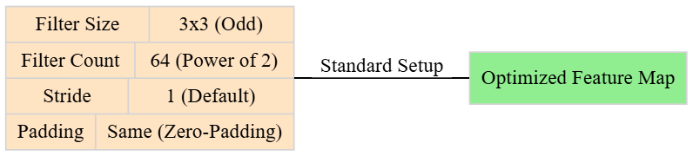

5. Conclusion / Summary
In summary, the ReLU Layer is an indispensable part of the CNN pipeline that provides the necessary non-linearity for complex pattern recognition. By utilizing a simple $max\left(0,x\right)$ function, it ensures computational efficiency, promotes feature sparsity, and enables the training of deep networks by mitigating gradient-related issues. Its ability to selectively activate neurons based on positive feature presence is what allows CNNs to achieve state-of-the-art accuracy in modern computer vision tasks.

Question: Discuss the role of the ReLU layer in CNNs. How does ReLU differ from other activation functions, and why is it preferred in convolutional layers? (May 2025)

1. Definition / Introduction
The ReLU (Rectified Linear Unit) Layer is a fundamental non-linear activation component in a Convolutional Neural Network (CNN) architecture. It is typically applied immediately after every convolutional operation to transform the linear output of the convolution into a non-linear representation. In the context of deep learning, ReLU acts as a mathematical gate that allows positive signals to pass through unchanged while blocking negative signals. This introduction of non-linearity is what enables a CNN to learn and model complex, high-dimensional patterns that are not merely linear combinations of the input pixels.

2. Detailed Explanation

A. The Role of the ReLU Layer
The ReLU layer operates by applying a simple mathematical function to every individual element in the input feature map. The operation performed by a ReLU neuron is defined as $f\left(x\right)=max\left(0,x\right)$. If an input value $x$ is positive ($x>0$), the output is $x$, maintaining the intensity of the detected feature. If $x$ is negative or zero ($x≤0$), the output is $0$, effectively “extinguishing” or silencing the signal.

B. Differences from Other Activation Functions
ReLU differs significantly from traditional activation functions like Sigmoid or Tanh:
- Saturation: Sigmoid and Tanh functions “saturate” at their extreme values (0 or 1 for Sigmoid; -1 or 1 for Tanh), causing gradients to become nearly zero during backpropagation. ReLU does not saturate for positive values, ensuring a constant gradient of 1 for all positive inputs.
- Range: While Sigmoid outputs are limited to $\left(0,1\right)$ and Tanh to $\left(-1,1\right)$, ReLU has a range of $[0,∞)$, allowing for more varied activation intensities.
- Linearity: Unlike the fully smooth curves of older functions, ReLU is a piecewise linear function that is linear for half its domain and zero for the other half.

C. Why ReLU is Preferred in Convolutional Layers
ReLU is the “gold standard” activation function for modern CNN hidden layers for several reasons:
- Overcoming the Vanishing Gradient Problem: By maintaining a constant gradient for positive inputs, ReLU allows error signals to flow more effectively through many deep layers during training, which is essential for deep convolutional architectures.
- Sparsity and Efficiency: By setting all negative values to zero, ReLU results in sparse activations, meaning only a subset of neurons are active at any given time. This makes the network more computationally efficient and helps extract the most prominent features while ignoring irrelevant noise.
- Speed of Computation: ReLU only requires a simple thresholding operation at zero, making it much faster to compute than the complex exponential calculations required for Sigmoid or Tanh.

3. Key Points
- Mathematical Gate: Selectively passes positive signals while blocking negative ones.
- Non-Linearity: Essential for breaking the linearity of convolution operations to model complex visual patterns.
- Default Choice: Standard activation for almost all modern CNN architectures due to its efficiency.
- Limitations: May suffer from the “Dying ReLU” problem, where neurons become permanently inactive if their weights are updated such that they always output zero.

4. Diagram
The following Graphviz code illustrates the mathematical behavior of the ReLU activation function.

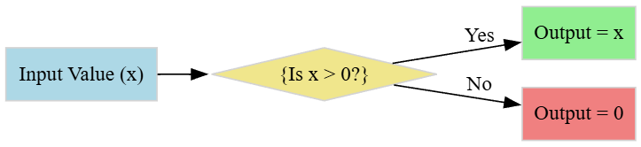

5. Conclusion / Summary
In summary, the ReLU Layer is an indispensable part of the CNN pipeline that provides the necessary non-linearity for complex pattern recognition. By utilizing a simple $max\left(0,x\right)$ function, it ensures computational efficiency, promotes feature sparsity, and enables the training of very deep networks by mitigating gradient-related issues like the vanishing gradient problem. Its ability to selectively activate neurons based on positive feature presence is what allows CNNs to achieve state-of-the-art accuracy in modern computer vision tasks.

Topic: 5. Pooling

1. Definition / Introduction
Pooling is a fundamental downsampling operation in a Convolutional Neural Network (CNN) that reduces the spatial dimensions (Width $×$ Height) of input feature maps while retaining the most important information. It is typically inserted periodically between successive convolutional layers to manage the computational complexity of the network. In the context of deep learning, pooling serves to make the detected features robust against small translations, distortions, or shifts in the input image.

2. Detailed Explanation
The pooling operation works by sliding a window (usually $2×2$) over the input feature map and summarizing the values within that window into a single output value.

A. Spatial Dimensionality Reduction
As an image passes through convolutional layers, the number of feature maps (depth) often increases, leading to a massive number of parameters. Pooling helps combat this by aggressively reducing the spatial resolution. For instance, a $2×2$ pooling window with a stride of 2 halves both the width and height, reducing the total number of pixels in the feature map by 75%.

B. The Process of Downsampling
- Window Selection: A window size (e.g., $2×2$ or $3×3$) is chosen.
- Stride Application: The window moves across the input according to a specified stride, typically equal to the window size to avoid overlapping.
- Aggregation: A mathematical function (Max or Average) is applied to the values in the window to produce a single scalar.

C. Translation Invariance
A key structural purpose of pooling is to provide translation invariance. Because the layer only cares about the presence of a feature within a local region rather than its exact pixel coordinates, the network can still recognize an object even if it is slightly shifted within the frame.

3. Key Points
- Dimensionality Management: Reduces the number of parameters and computational load, which helps prevent overfitting.
- Feature Robustness: Enhances the model’s ability to handle variations in object position and slight distortions.
- No Learnable Parameters: Unlike convolutional layers, pooling layers do not have weights or biases; they only perform a fixed mathematical operation.
- Common Settings: Most architectures use a $2×2$ filter with a stride of 2.
- Depth Preservation: While spatial dimensions are reduced, the depth (number of feature maps) remains unchanged.

4. Diagram / Example
The following Graphviz code illustrates a standard $2×2$ Max Pooling operation on a $4×4$ input resulting in a $2×2$ output.

5. Conclusion / Summary
In summary, the Pooling Layer is an essential component for building efficient and robust CNNs. By summarizing local features and reducing spatial resolution, it allows the network to focus on the most prominent information while significantly lowering computational costs. This mechanism of spatial abstraction is a primary driver behind the ability of modern deep learning models to achieve high accuracy in complex image recognition tasks.

Question: Describe the concept of pooling in CNNs and explain how it contributes to spatial dimensionality reduction. What are some common pooling methods, and how do they differ? (May 2025)

1. Definition / Introduction
Pooling is a fundamental downsampling operation in a Convolutional Neural Network (CNN) designed to reduce the spatial dimensions (Width $×$ Height) of input feature maps while retaining the most salient information. It is typically inserted periodically between successive convolutional layers to manage the computational complexity of the network.
In the context of deep learning, pooling serves a dual purpose: it aggressively combats the “curse of dimensionality” by shrinking the representation size and makes the detected features robust against small translations, distortions, or shifts in the input image.

2. Detailed Explanation

A. Contribution to Spatial Dimensionality Reduction
As an image passes through multiple convolutional layers, the number of feature maps (depth) often increases, leading to a massive expansion in the number of parameters. Pooling is the primary mechanism used to handle this:
- The Aggregation Process: The pooling operation slides a fixed-size window (usually $2×2$) over the input feature map and summarizes the values within that window into a single output value.
- Resolution Halving: For instance, applying a $2×2$ pooling window with a stride of 2 halves both the width and height of the map. This reduces the total number of pixels in the feature map by 75%, significantly lowering the computational load for subsequent layers.

B. Common Pooling Methods
There are two predominant types of pooling used in modern architectures:
- Max Pooling:
  - Mechanism: It selects the maximum value from every sub-region covered by the filter.
  - Role: It is highly effective at capturing the most prominent features (like edges or textures) and is the most common choice in state-of-the-art models.
- Average Pooling:
  - Mechanism: It calculates the average of all values within the window.
  - Role: It provides a smoother, generalized summary of the feature map but may sometimes “wash out” fine details compared to Max Pooling.

C. How They Differ
The primary difference lies in their feature selection logic:
- Max Pooling is deterministic and focuses on the “strongest” signal, making it excellent for detecting sharp features.
- Average Pooling considers every pixel in the window equally, providing a more “blurry” or averaged representation that can be useful in specific architectures where global context is more important than local intensity.

3. Key Points
- Dimensionality Management: Aggressively reduces the number of parameters to prevent overfitting and save memory.
- Translation Invariance: Because it summarizes a local region, the network can recognize a feature even if its exact pixel coordinates shift slightly.
- No Learnable Parameters: Unlike convolutional layers, pooling layers perform a fixed mathematical operation and do not require weights or biases to be trained.
- Depth Preservation: While the spatial width and height are shrunk, the number of feature maps (depth) remains entirely unchanged.
- Common Settings: The industry standard is typically a $2×2$ filter with a stride of 2.

4. Diagram / Example
The following Graphviz code illustrates a standard $2×2$ Max Pooling operation that transforms a $4×4$ input into a $2×2$ output.

5. Conclusion / Summary
In summary, the Pooling Layer is an essential architectural tool that ensures CNNs remain computationally viable as they grow deeper. By summarizing local features through mathematical aggregation (Max or Average), it achieves significant spatial dimensionality reduction while granting the model a degree of robustness against image distortions. This process of spatial abstraction is a primary driver behind the high accuracy achieved by modern deep learning models in complex visual recognition tasks.

Question: What is pooling in CNNs? Why is it used? Explain the difference between max pooling and average pooling. (May 2024) (Repeated Question)

1. Definition / Introduction
Pooling is a fundamental downsampling operation in a Convolutional Neural Network (CNN) designed to reduce the spatial dimensions (Width $×$ Height) of input feature maps while retaining the most salient information. It is typically inserted periodically between successive convolutional layers to manage the computational complexity of the network.
In the context of deep learning, pooling serves a dual purpose: it aggressively combats the “curse of dimensionality” by shrinking the representation size and makes the detected features robust against small translations, distortions, or shifts in the input image.

2. Detailed Explanation

A. Contribution to Spatial Dimensionality Reduction
As an image passes through multiple convolutional layers, the number of feature maps (depth) often increases, leading to a massive expansion in the number of parameters. Pooling is the primary mechanism used to handle this:
- The Aggregation Process: The pooling operation slides a fixed-size window (usually $2×2$) over the input feature map and summarizes the values within that window into a single output value.
- Resolution Halving: For instance, applying a $2×2$ pooling window with a stride of 2 halves both the width and height of the map. This reduces the total number of pixels in the feature map by 75%, significantly lowering the computational load for subsequent layers.

B. Common Pooling Methods
There are two predominant types of pooling used in modern architectures:
- Max Pooling:
  - Mechanism: It selects the maximum value from every sub-region covered by the filter.
  - Role: It is highly effective at capturing the most prominent features (like edges or textures) and is the most common choice in state-of-the-art models.
- Average Pooling:
  - Mechanism: It calculates the average of all values within the window.
  - Role: It provides a smoother, generalized summary of the feature map but may sometimes “wash out” fine details compared to Max Pooling.

C. How They Differ
The primary difference lies in their feature selection logic:
- Max Pooling is deterministic and focuses on the “strongest” signal, making it excellent for detecting sharp features like edges or high-intensity motifs.
- Average Pooling considers every pixel in the window equally, providing a more “blurry” or averaged representation that can be useful in specific architectures where global context is more important than local peak intensity.

3. Key Points
- Dimensionality Management: Aggressively reduces the number of parameters to prevent overfitting and save memory.
- Translation Invariance: Because it summarizes a local region, the network can recognize a feature even if its exact pixel coordinates shift slightly.
- No Learnable Parameters: Unlike convolutional layers, pooling layers perform a fixed mathematical operation and do not require weights or biases to be trained.
- Depth Preservation: While the spatial width and height are shrunk, the number of feature maps (depth) remains entirely unchanged.
- Common Settings: The industry standard is typically a $2×2$ filter with a stride of 2.

4. Diagram / Example
The following Graphviz code illustrates a standard $2×2$ Max Pooling operation that transforms a $4×4$ input into a $2×2$ output.

5. Conclusion / Summary
In summary, the Pooling Layer is an essential architectural tool that ensures CNNs remain computationally viable as they grow deeper. By summarizing local features through mathematical aggregation (Max or Average), it achieves significant spatial dimensionality reduction while granting the model a degree of robustness against image distortions. This process of spatial abstraction is a primary driver behind the high accuracy achieved by modern deep learning models in complex visual recognition tasks.

Topic: 6. Fully Connected Layers

1. Definition / Introduction
A Fully Connected (FC) Layer, also known as a Dense Layer, is a traditional Multi-Layer Perceptron (MLP) component typically placed at the end of a Convolutional Neural Network (CNN) architecture. In this layer, every neuron in the current layer is connected to every single neuron in the previous layer.
While the preceding convolutional and pooling layers act as automated feature extractors to identify local patterns, the Fully Connected Layers act as the global “reasoning engine” or “classifier.” They take the high-level features learned by the convolutional base and map them to the final output classes (e.g., identifying whether an image is a “Cat” or a “Dog”).

2. Detailed Explanation
The transition to and the operation within the Fully Connected layers involve several critical steps:

A. The Flattening Process
Before data can enter an FC layer, the 3D output of the final pooling layer (Height $×$ Width $×$ Depth) must be converted into a 1D vector. This is called Flattening. For example, if the final feature map is $7×7$ with 512 filters, it is flattened into a single 1D vector of $7×7×512=25,088$ elements.

B. Mathematical Operation
The operation in a Fully Connected layer is a simple linear transformation followed by an activation function. For an input vector $x$, the output $y$ is calculated as:
$$y=f\left(W⋅x+b\right)$$
- $W$: The weight matrix representing the strength of connections between all input and output neurons.
- $b$: The bias vector.
- $f$: The activation function (usually ReLU for hidden FC layers and Softmax for the final output layer).

C. Role in Feature Integration
While convolutional layers are spatially constrained (looking only at local patches), FC layers have a global receptive field. They look at the entire set of features extracted from across the whole image simultaneously. This allow the network to understand the relationship between different parts of an object (e.g., “if there are two eyes, a nose, and whiskers in these relative locations, it is a cat”).

D. The Output Layer
The final FC layer usually has a number of neurons equal to the number of target classes. In multi-class classification, a Softmax activation is used to turn the raw output scores (logits) into probabilities that sum to 1.

3. Key Points
- Global Reasoning: Integrates all local features extracted by the convolutional layers to make a final classification decision.
- High Parameter Count: Unlike convolutional layers that use weight sharing, FC layers have a massive number of parameters, making them the most memory-intensive part of the CNN.
- Loss of Spatial Structure: Once the data is flattened into the FC layer, the 2D spatial arrangement of the pixels is discarded.
- Positioning: Almost always positioned at the very end of the network, following the feature extraction phase.
- Overfitting Risk: Due to the high number of connections, FC layers are prone to overfitting, often requiring regularization techniques like Dropout.

4. Diagram / Example
The following Graphviz code illustrates the transition from a 3D Feature Map to a 1D Fully Connected structure for classification.

5. Conclusion / Summary
In summary, Fully Connected Layers are the decision-making components of a CNN. They bridge the gap between high-dimensional feature maps and final class predictions. By connecting every extracted feature to every potential output class, they provide the model with the necessary complexity to perform logical grouping and classification, completing the pipeline from raw pixel input to intelligent prediction.

Topic: 7. The Interleaving between Layers

1. Definition / Introduction
The Interleaving between Layers refers to the strategic structural arrangement and sequencing of different functional layers—specifically Convolutional, Activation (ReLU), and Pooling layers—within a CNN architecture. In a deep learning pipeline, layers are not placed randomly; they are “interleaved” to create a balanced flow that transforms raw pixels into abstract semantic features.
This pattern of interleaving is the architectural hallmark of CNNs, allowing the network to perform hierarchical feature extraction where each interleaved “block” progressively refines the spatial and conceptual understanding of the input data.

2. Detailed Explanation
The interleaving process typically follows a repetitive block-based structure. The logic behind this sequencing is fundamental to how CNNs achieve state-of-the-art performance.

A. The Standard Interleaving Sequence
The most common pattern in modern CNNs (like VGG or ResNet) is the repetition of the following block:
- Convolutional Layer: Learns linear spatial filters.
- ReLU Layer: Injects non-linearity immediately after the convolution.
- Pooling Layer: Downsamples the representation after several convolutions.

B. Interleaving Multiple Convolutions
Modern architectures often interleave multiple convolutional layers before a single pooling layer (e.g., Conv $→$ ReLU $→$ Conv $→$ ReLU $→$ Pool).
- Reasoning: Stacking two $3×3$ convolutions has the same effective receptive field as a single $5×5$ convolution but includes an extra non-linear ReLU layer. This makes the interleaving “deeper” and more expressive without increasing the number of parameters excessively.

C. Transition from Local to Global
As the network progresses, the interleaving pattern changes:
- Early Interleaving: Focuses on high spatial resolution with few filters. The interleaving is dense to capture fine details (edges/textures).
- Late Interleaving: As the data moves toward the Fully Connected layers, the spatial resolution is aggressively reduced via pooling, while the number of filters increases. The interleaving here focuses on complex object parts.

D. Role of Non-linear Interleaving
If we did not interleave ReLU between convolutional layers, stacking multiple convolutions would be mathematically equivalent to a single linear operation. Interleaving an activation function after every linear transformation is what allows the deep structure to approximate complex, non-linear boundaries between classes.

3. Key Points
- Hierarchical Abstraction: Interleaving ensures that the network builds a hierarchy, starting from pixels and moving to edges, motifs, parts, and objects.
- Feature Refinement: Convolutional layers extract features, while interleaved pooling layers provide a “summary” and translation invariance.
- Dimensionality Control: Strategic interleaving of pooling and strided convolutions prevents the memory requirements from exploding.
- Expressivity: Adding non-linear activations between linear layers increases the model’s capacity to learn complex functions.
- Standard Block Design: Most modern architectures are essentially many of these interleaved blocks stacked on top of each other.

4. Diagram / Example
The following Graphviz code illustrates a typical interleaved block structure within a deep CNN.
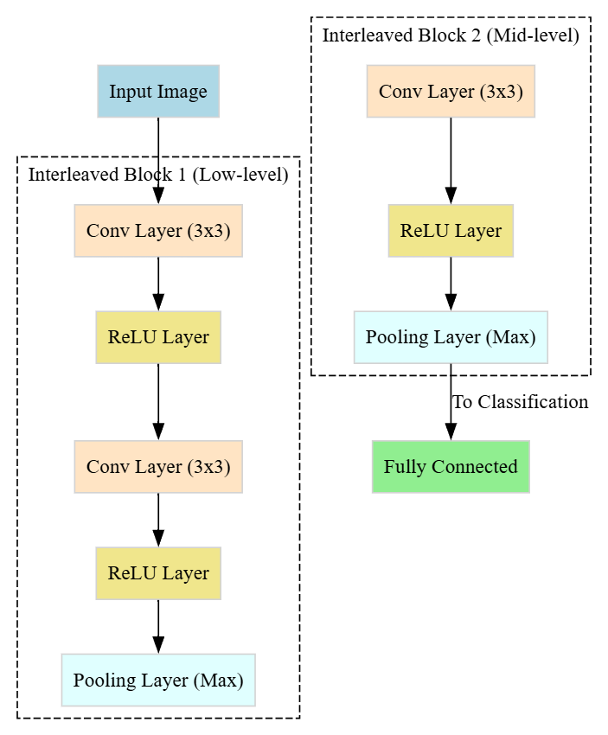

5. Conclusion / Summary
In summary, The Interleaving between Layers is the “grammar” of CNN design. By carefully alternating between Convolution (for feature learning), ReLU (for non-linearity), and Pooling (for spatial efficiency), the architecture creates a powerful pipeline capable of distilling complex visual information. Without this specific interleaving, the network would lack either the depth to learn complex patterns or the efficiency to handle high-resolution data.
No PYQs exist for this specific sub-topic in the provided papers.

Topic: 8. Local Response Normalization

1. Definition / Introduction
Local Response Normalization (LRN) is a non-trainable layer used in earlier Convolutional Neural Network architectures (most notably AlexNet) to implement a form of lateral inhibition. Lateral inhibition is a biological concept found in real neurons, where an excited neuron tends to reduce the activity of its neighbors.
In the context of CNNs, LRN normalizes the output of a neuron based on the activity of adjacent neurons across different feature maps (channels) at the same spatial location. The primary goal is to encourage “competition” between different filters, allowing the most prominent features to stand out while dampening high-frequency but less significant noise.

2. Detailed Explanation
LRN is typically applied after the activation function (like ReLU). While modern architectures often prefer Batch Normalization, understanding LRN is essential for studying the evolution of deep learning and specific “Typical Settings” of historic models.

A. Mathematical Logic
The normalization is performed across “neighborhoods” of feature maps. For a given activity $a_{x,y}^{i}$ of a kernel $i$ at position $\left(x,y\right)$, the response-normalized activity $b_{x,y}^{i}$ is given by:
$$b_{x,y}^{i}=\frac{a_{x,y}^{i}}{{\left(k+α\sum_{j=max\left(0,i-n/2\right)}^{min\left(N-1,i+n/2\right)}{{\left(a_{x,y}^{j}\right)}^{2}}\right)}^{β}}$$
Where:
- $n$: The number of “adjacent” kernel maps used for normalization.
- $N$: Total number of kernels in the layer.
- $k,α,β$: Hyperparameters (Typical settings are $k=2,n=5,α={10}^{-4},β=0.75$).

B. The Biological Basis
In the human eye, lateral inhibition increases the contrast and sharpness in visual response. In a CNN, if multiple filters detect similar patterns in the same area, LRN will dampen the weaker detections and amplify the strongest one. This prevents a single large activation from dominating the entire feature map volume and helps in generalizing the model.

C. Inter-Channel vs. Intra-Channel
- Inter-Channel (Across Maps): The most common type, where normalization occurs across a range of feature maps at the same pixel coordinate.
- Intra-Channel (Within Map): Normalization occurs within a local spatial window (e.g., $3×3$) of the same feature map.

3. Key Points
- Contrast Enhancement: Helps the network focus on the most distinguishing features by suppressing dampened neighboring neurons.
- Generalization: Acts as a regularizer, helping to reduce the generalization error (Top-1 and Top-5 error rates in early research).
- Non-Trainable: LRN does not have weights that change during backpropagation; it only has hyperparameters that are set before training.
- Replacement by Batch Norm: In modern engineering, LRN has largely been replaced by Batch Normalization, which normalizes across the mini-batch rather than local channel neighborhoods.
- Computational Cost: It adds a slight computational overhead during the forward pass due to the summation and power operations.

4. Diagram
The following diagram illustrates the concept of Inter-Channel normalization where a neuron is normalized by its neighbors in the “depth” dimension.
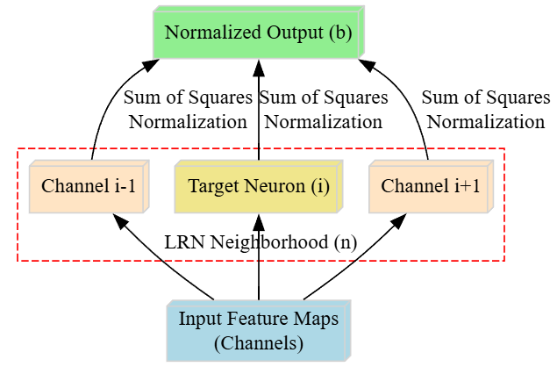

5. Conclusion / Summary
In summary, Local Response Normalization is a technique that mimics biological lateral inhibition to improve the contrast of detected features across channel maps. While it is less common in state-of-the-art architectures today, it remains a milestone in CNN design for its role in enabling the success of deep models like AlexNet. It ensures that the network learns a diverse set of features by preventing redundant or noisy activations from overwhelming the learning process.
No PYQs exist for this specific sub-topic in the provided papers.

Topic: 9. Training a Convolutional Network

1. Definition / Introduction
Training a Convolutional Network is the iterative process of optimizing the learnable parameters—specifically the weights in the convolutional filters and the fully connected layers—to minimize the error between the predicted output and the actual ground-truth label.
In the context of deep learning, training involves a supervised learning approach using the Backpropagation algorithm combined with an Optimization algorithm (like Stochastic Gradient Descent). The goal is to enable the network to automatically discover the best set of spatial filters that can extract discriminating features from raw pixel data for a given task.

2. Detailed Explanation
The training of a CNN is a multi-stage cycle that is repeated over many epochs until the model converges.

A. Forward Pass
Data flows from the input layer through the interleaved convolutional, activation, and pooling layers.
- The raw pixels are transformed into high-level feature vectors.
- The final fully connected layer produces a prediction (e.g., class probabilities via Softmax).
- A Loss Function (such as Cross-Entropy Loss) calculates the “cost” or the difference between the prediction and the true label.

B. Backward Pass (Backpropagation)
This is the “learning” phase where the error is sent backward through the network.
- Using the Chain Rule of Calculus, the gradient of the loss function is calculated with respect to every weight and bias in the network.
- For convolutional layers, the gradients are calculated for the shared weights of the filters, ensuring that the filter learns to detect features that help reduce the overall error.

C. Weight Update (Optimization)
An optimizer (e.g., Adam, SGD, or RMSProp) updates the weights using the calculated gradients and a Learning Rate ($η$).
- Formula: $W_{new}=W_{old}-η⋅\frac{∂Loss}{∂W}$
- The learning rate controls how large a step is taken toward the minimum of the loss function.

D. Batch Processing
CNNs are rarely trained on one image at a time. Instead, they use Mini-batch Gradient Descent, where a small group of images (e.g., batch size of 32 or 64) is processed together. This provides a more stable estimate of the gradient and speeds up computation by leveraging GPU parallelism.

3. Key Points
- End-to-End Learning: The network learns the filters and the classifier simultaneously; no manual feature extraction is required.
- Data Augmentation: To prevent overfitting during training, input images are often randomly flipped, rotated, or cropped to artificially increase dataset variety.
- Hyperparameters: Success depends on tuning the learning rate, batch size, number of epochs, and weight initialization strategies.
- Regularization: Techniques like Dropout (randomly disabling neurons) and Weight Decay ($L2$ regularization) are used to ensure the model generalizes well to unseen data.
- Convergence: Training stops when the loss on a separate validation set stops decreasing, a technique known as Early Stopping.

4. Diagram
The following Graphviz code represents the iterative training loop of a Convolutional Neural Network.

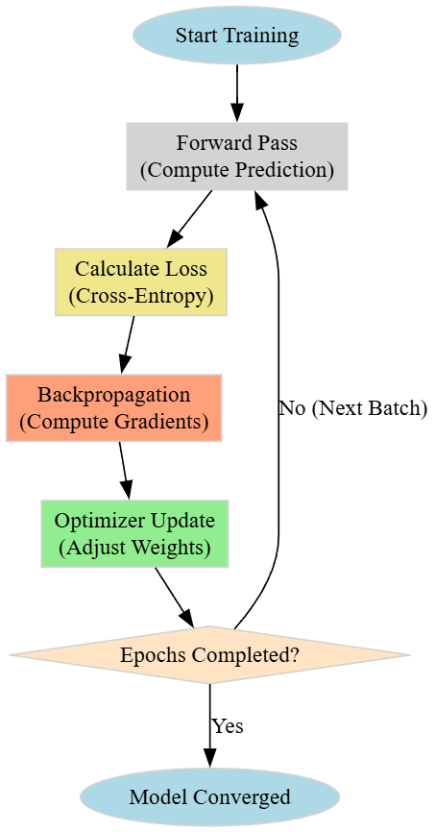

5. Conclusion / Summary
In summary, Training a Convolutional Network is a systematic process of refining filter weights through the combination of forward propagation, loss calculation, and backpropagation. By iteratively adjusting parameters to minimize error, the network evolves from a random state into a sophisticated feature extractor and classifier. Effective training requires a balance of proper optimization, careful hyperparameter selection, and regularization to ensure the model performs accurately on real-world, unseen images.
No PYQs exist for this specific sub-topic in the provided papers.

